Week Two – 12-02-2018

Rather than working on the computer, we decided to work on the lab wall to allow each us all to see the layout easier than on a limited sized computer screen. We had the previous week decided to work separately so as not influence each other’s through processes. Once the lab began we combined our work, discussed what was missing, where to place each post-it and consulted with one of the demonstrators and our lecturer, Dr. Casey. Before the feedback, the resulting layout was as seen in figure 1 below. Having through we were on the right track, we proceeded in creating a timetable to ascertain the tasks required and their time frames in order to delegate the workload between the team.

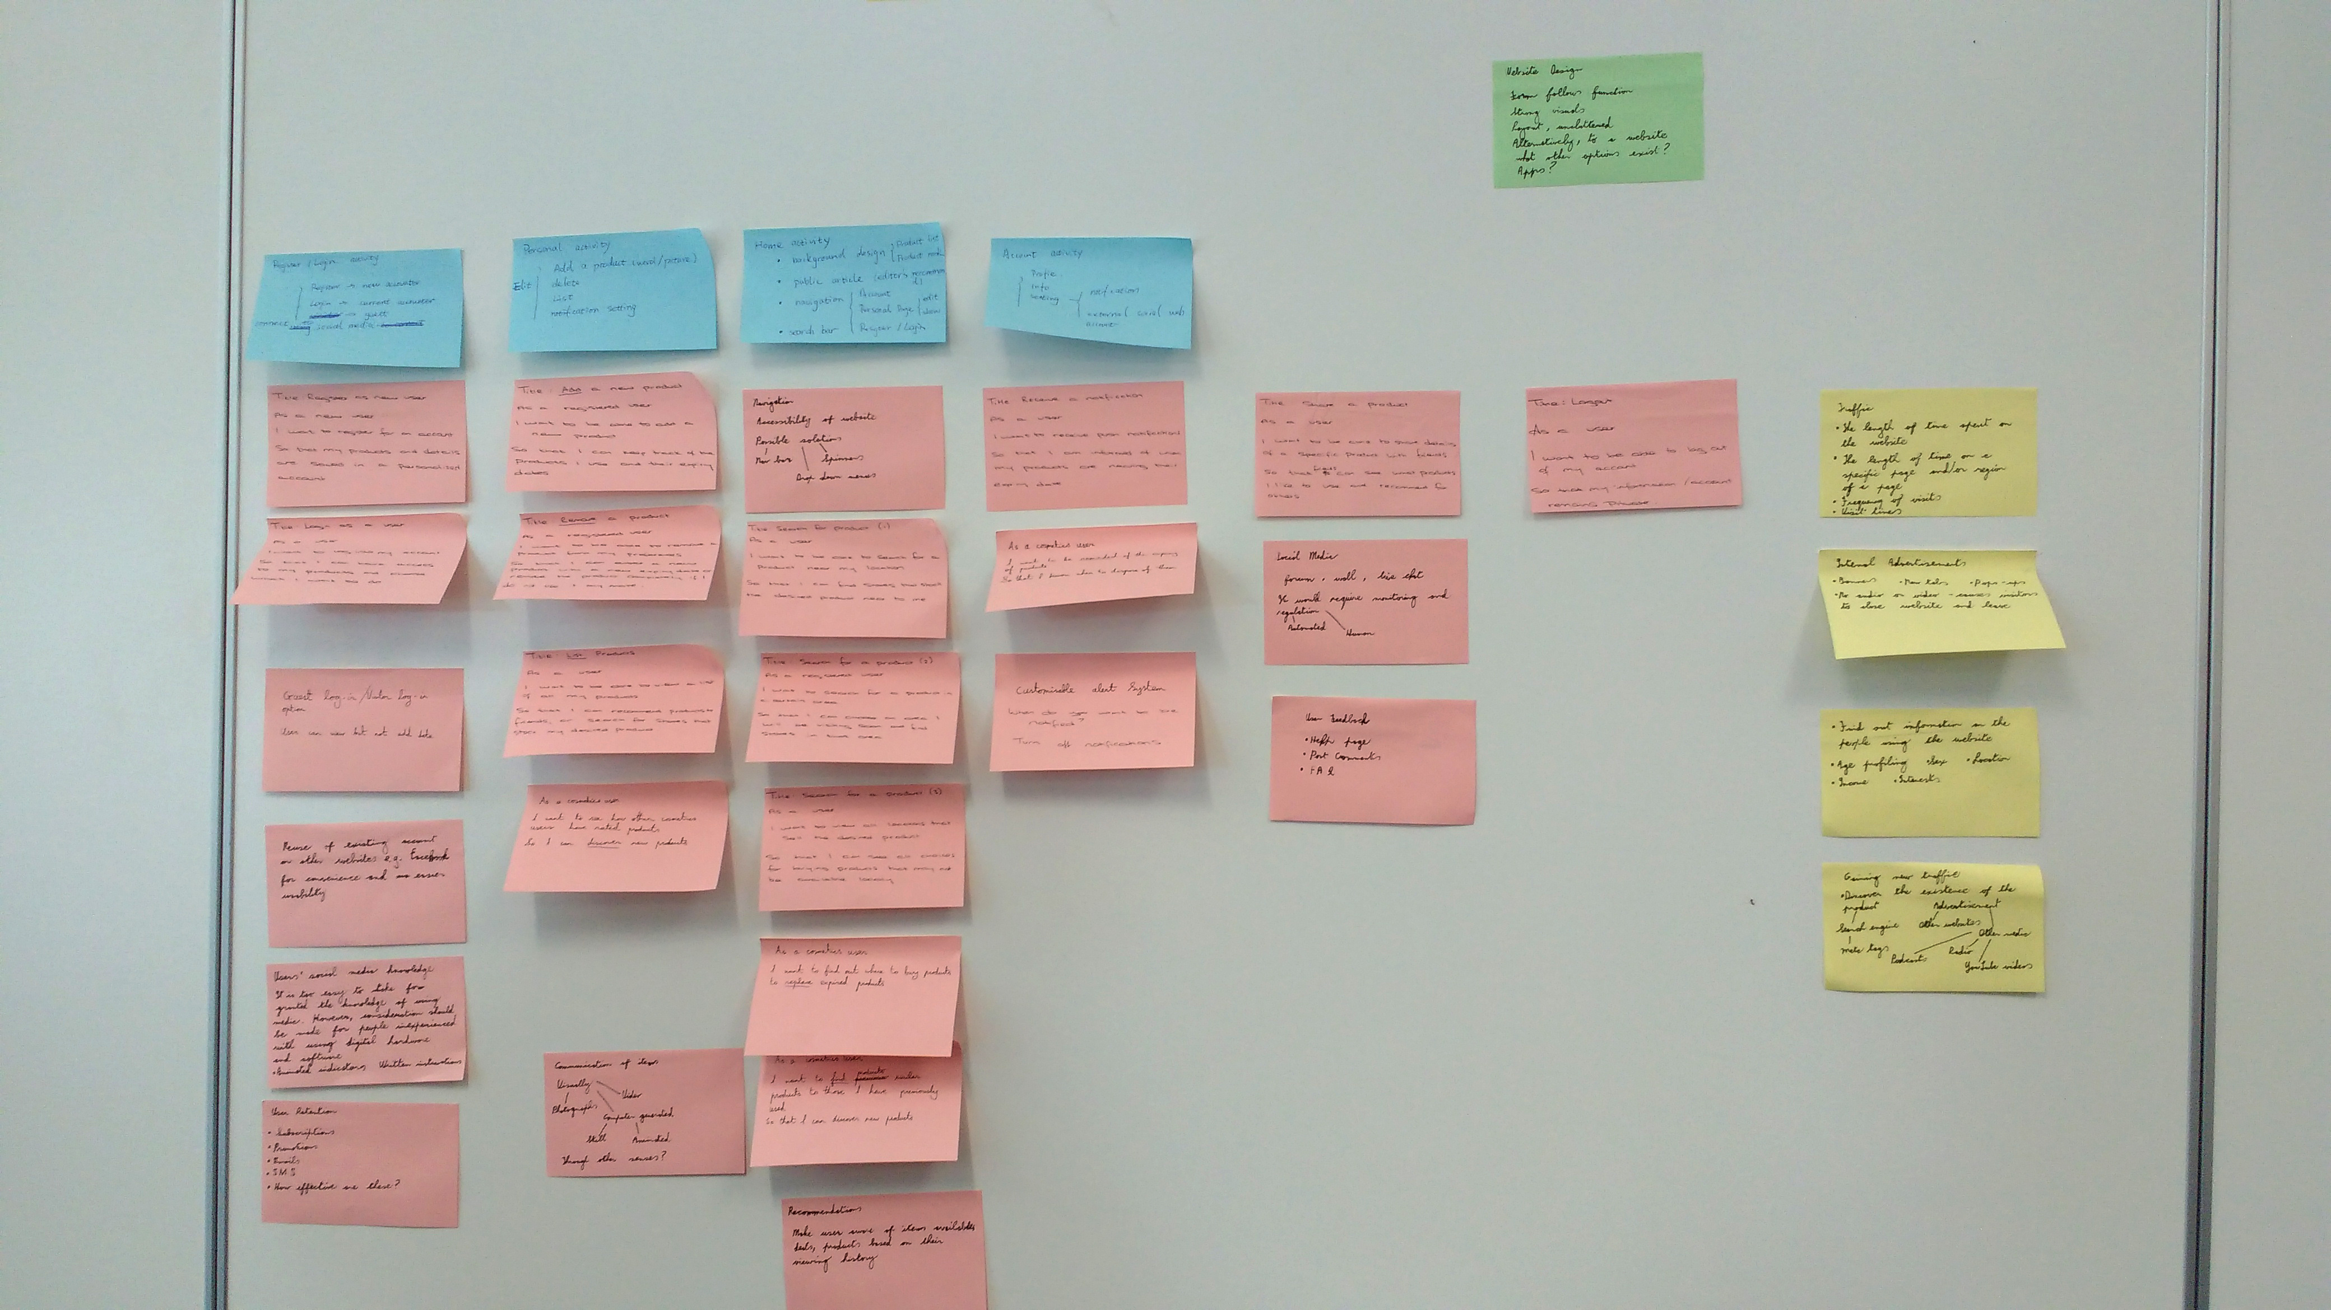  
  
FFfFig 1: User-Story first attempt

After consultation, it became apparent we got the layout wrong, although Lorraine’s post-its approached the user story correctly. Most of the post-its used in the second layout were hers’. However, we kept as much information as possible from all the post-its to aid in further development to come.

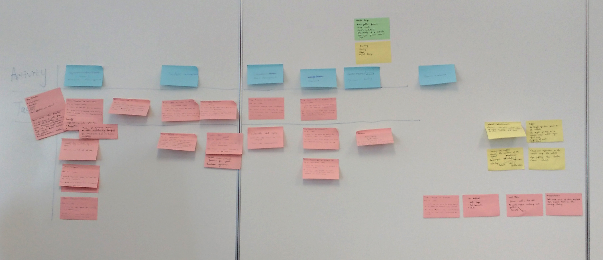

Fig 2: User-Story second attempt

FFfFig 1: User-Story first attempt  
FFfFig 1: User-Story first attemptFig2

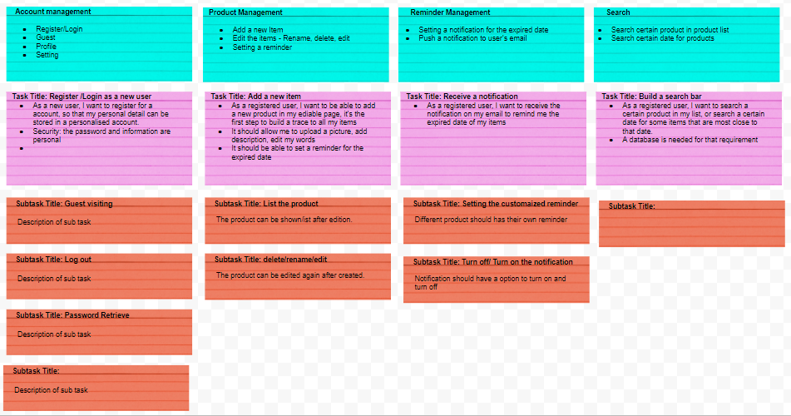

Fig3: User-Story digital version wip

Rachel tool the initiative in creating a digital version of the user story layout as shown in figure 3, from which Sean made a full version using Inkscape shown in figure 4, completed the following day.

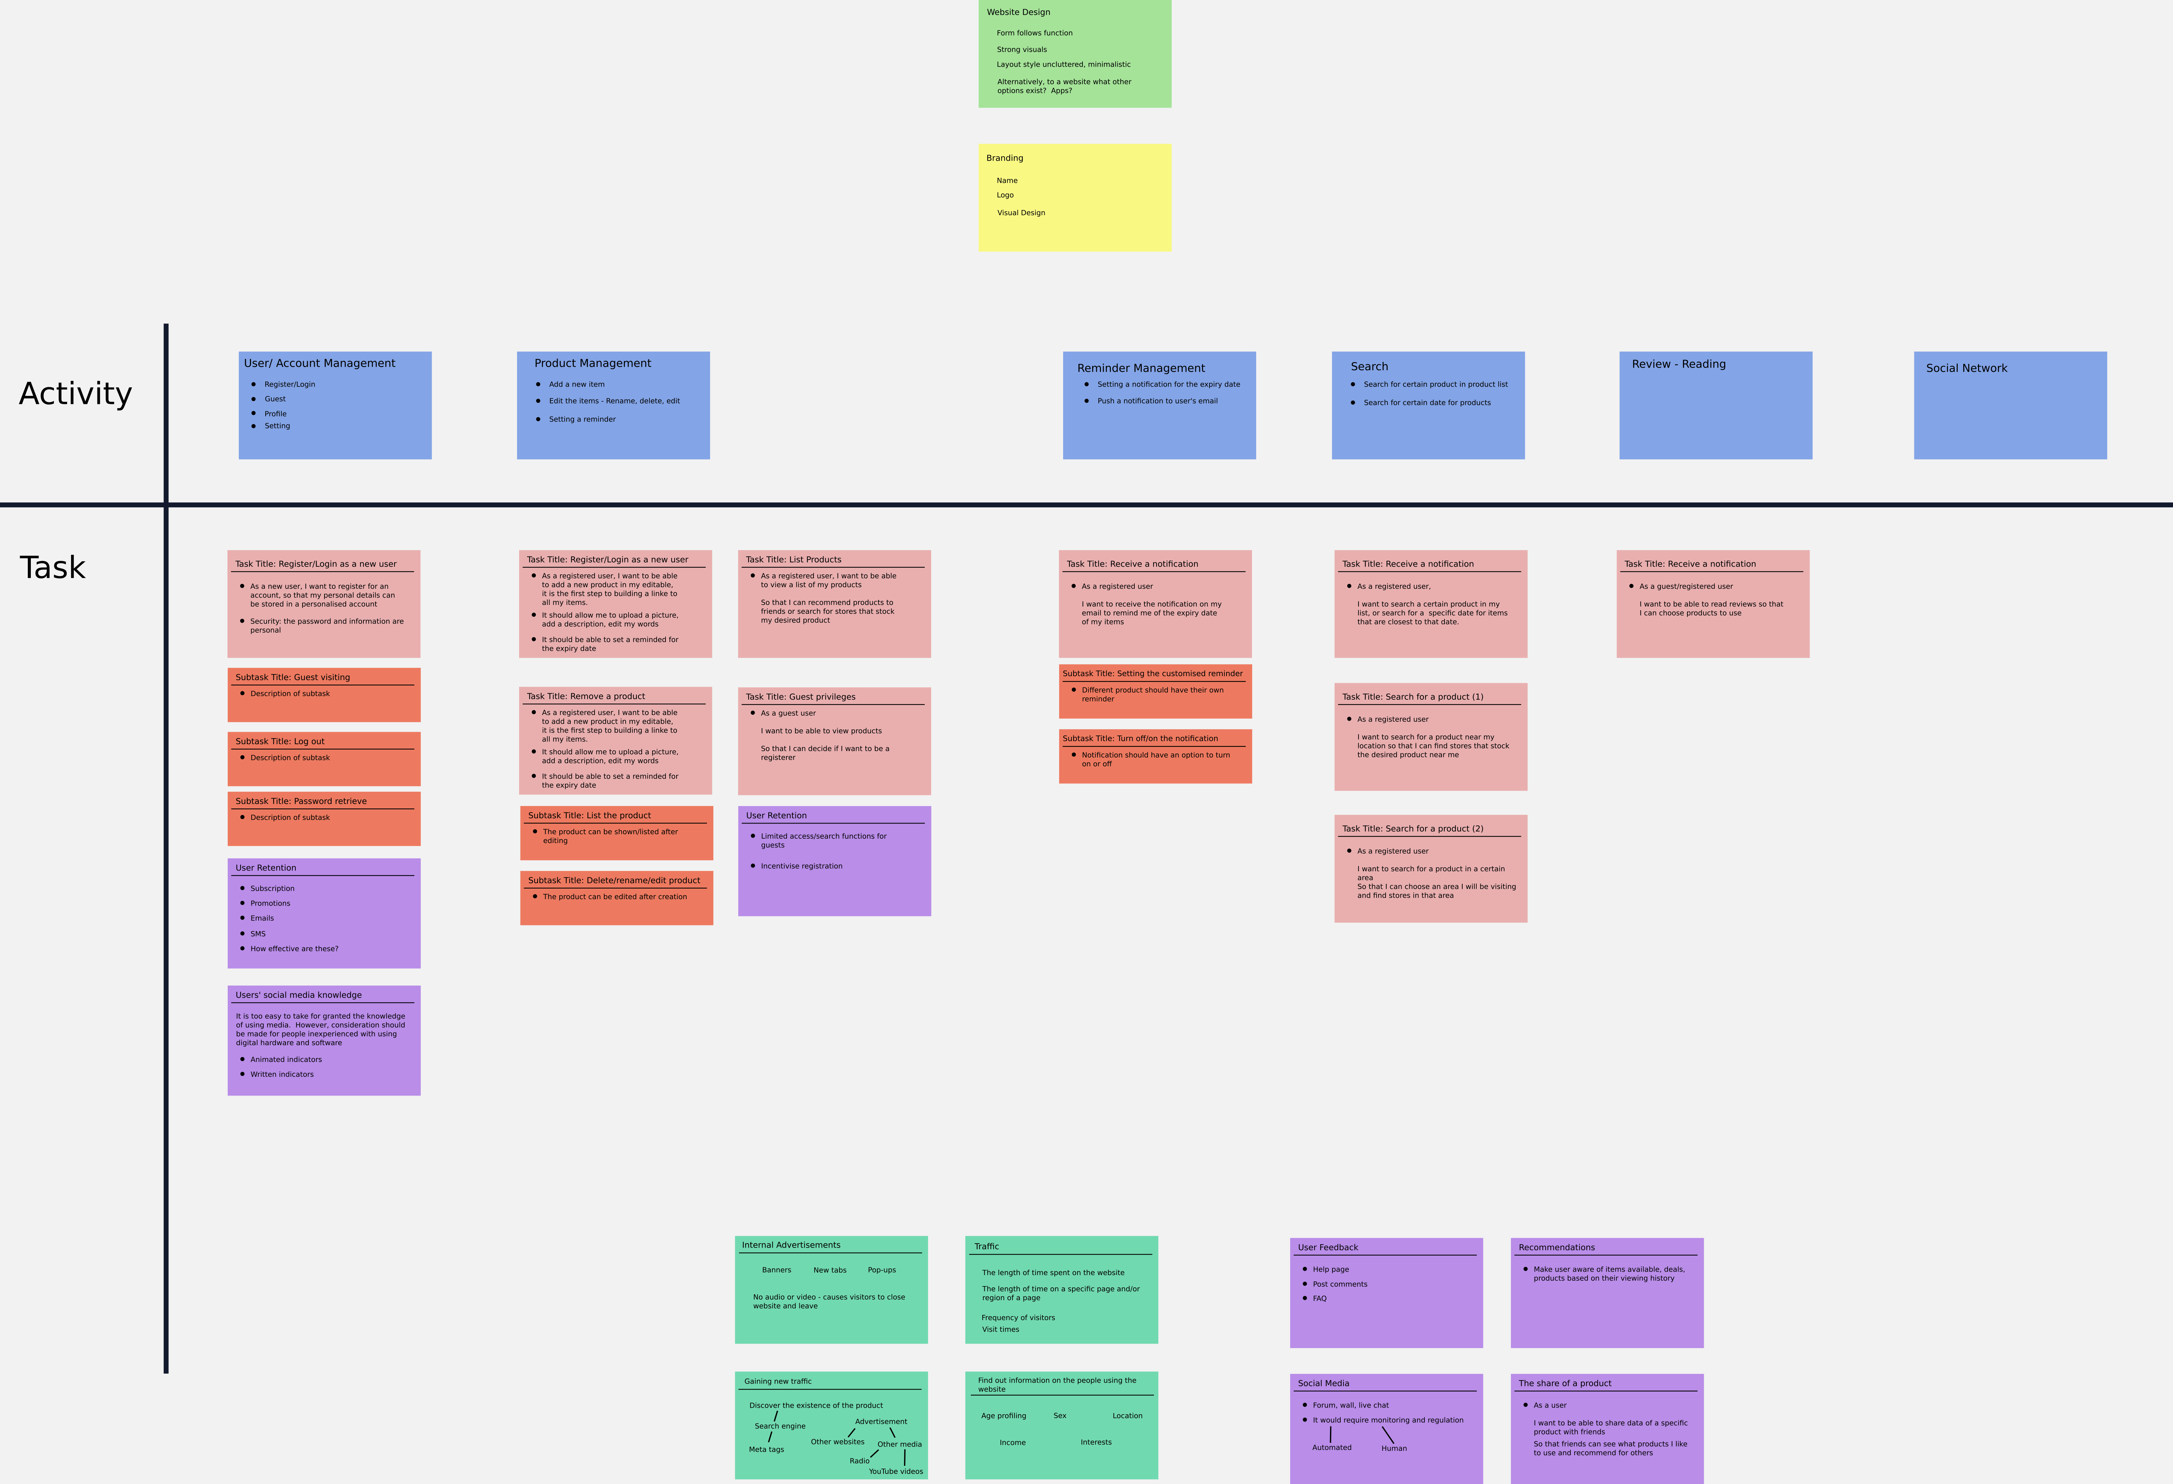Poker cards were printed out and prepared for use Monday, but we decided afterwards to leave it for a meeting during the week or the following Monday. Kevin was sketching out logo designed casually on his notepad, we decided to give him the task of designing the brand logo. Lorraine had already made a html layout with jQuery the previous week to enable us to learn how to use the languages required for web development.

Fig4: User-Story as a SVG